FIMS PURCHASE ORDER ACKNOWLEDGEMENT:-

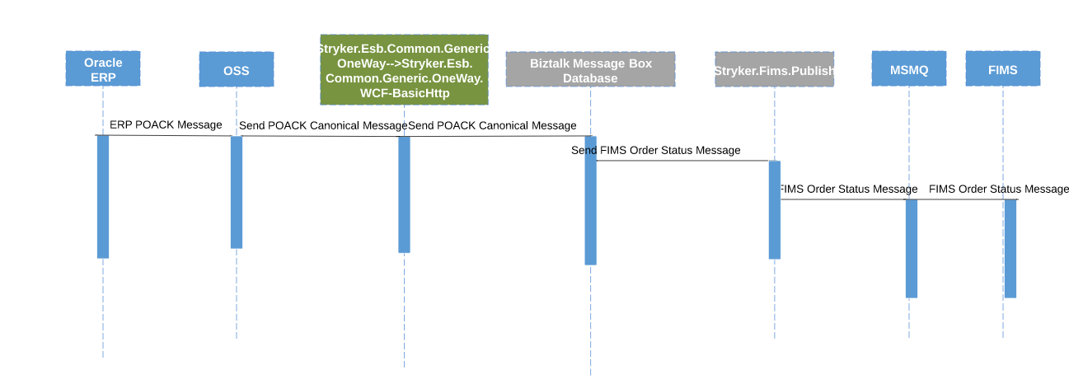

FIMS PURCHASE ORDER:-

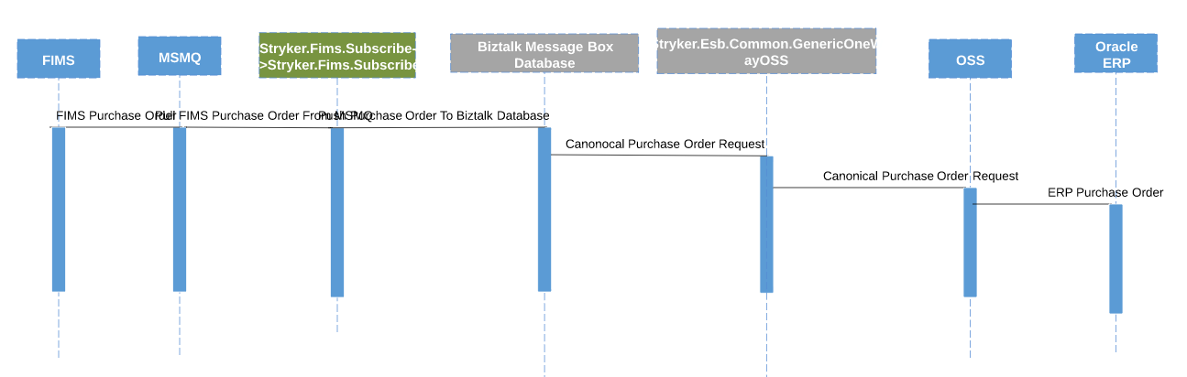

1. FIMS Purchase Order
2. 2. Pull FIMS Purchase Order From MSMQ
3. Push Purchase Order To Biztalk Database

FIMS INVENTORY:-

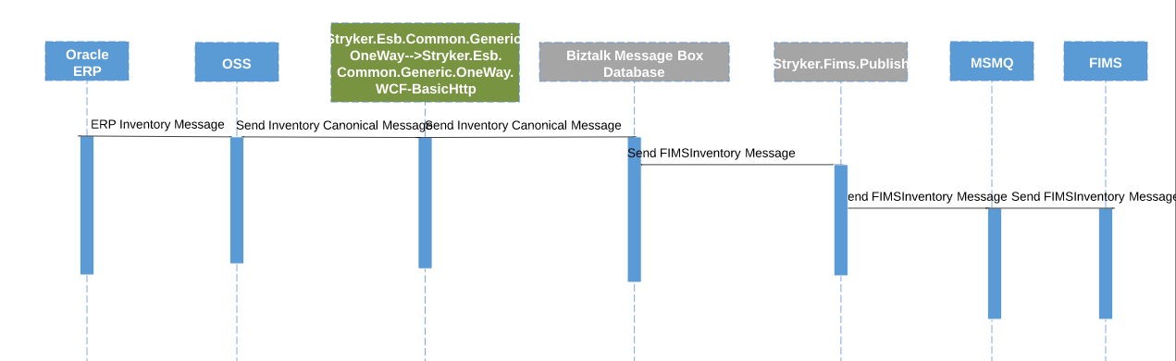

Fims items

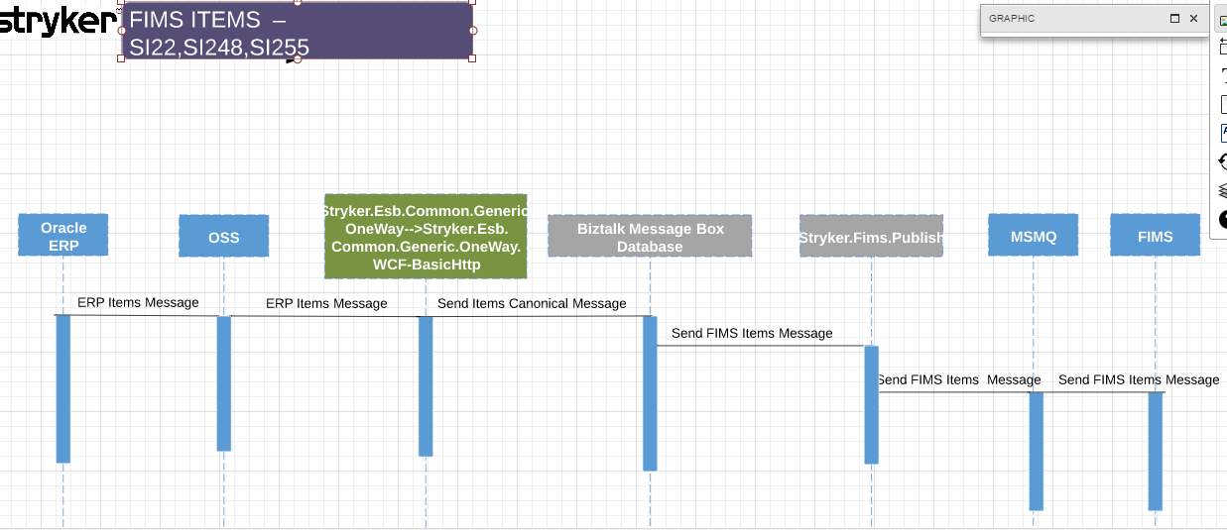

Fims customer:-

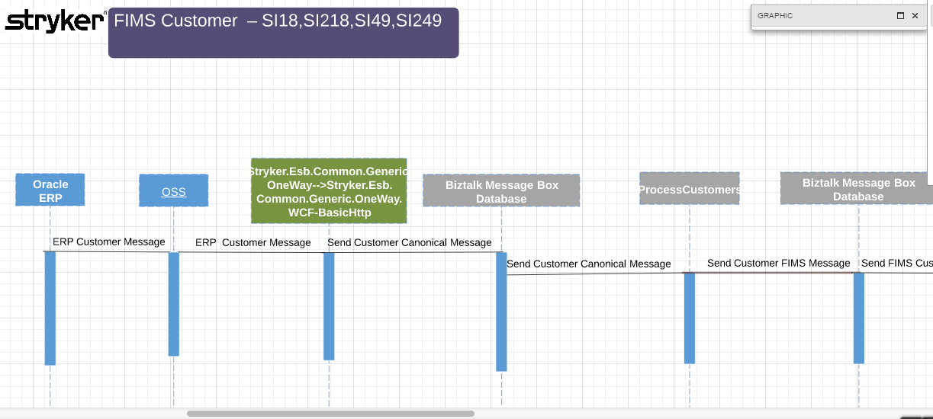

Continuation from above:-

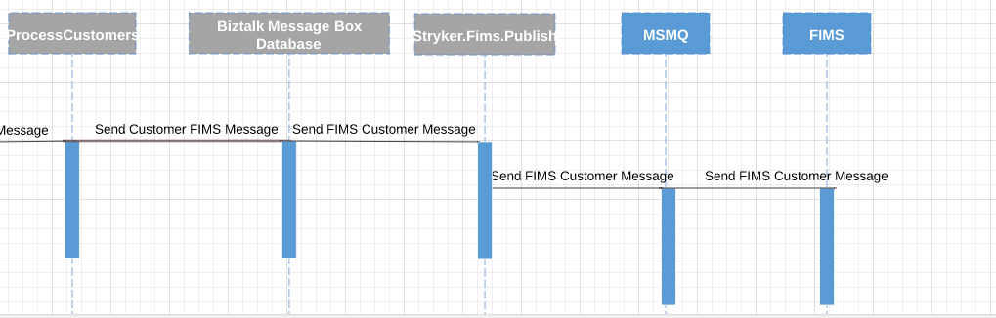

Fims shipment and return order

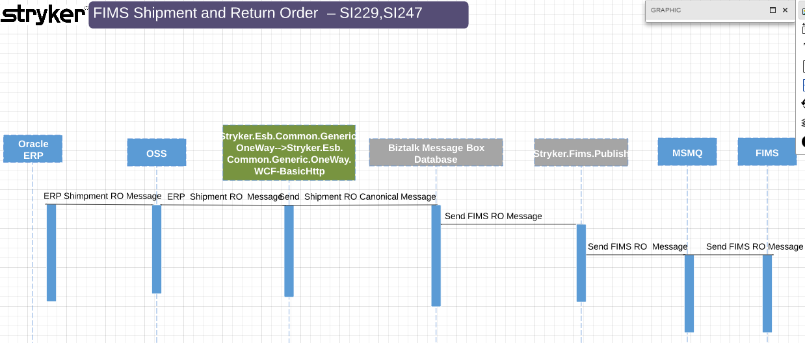

Fims limited release:-

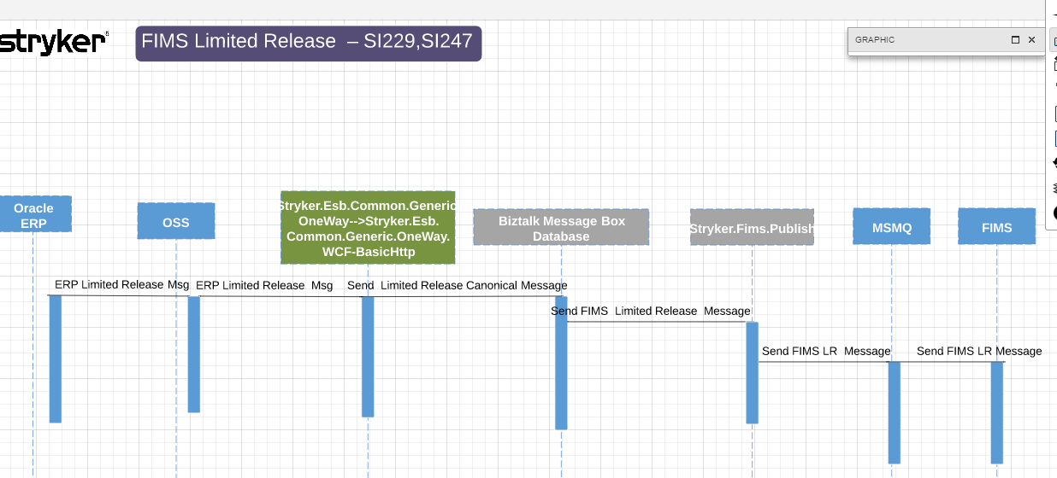

Fims quality notification:-

